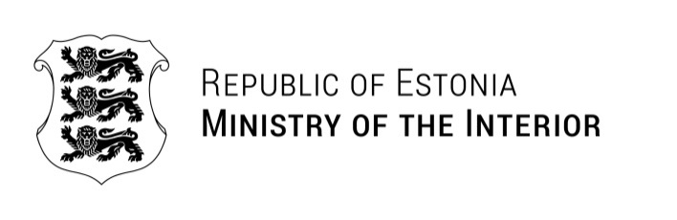
Ms. Mari Rantanen  Minister of the Interior of the Republic of Finland  Mr. Jānis Dombrava  Minister for the Interior of the Republic of Latvia  Mr. Martynas Katelynas  Minister of the Interior of the Republic of Lithuania  Mr. Marcin Kierwiński  Minister of Internal Affairs and Administration of the Republic of Poland  Mr. Tomasz Siemoniak  Minister, Member of the Council of Ministers, Coordinator of Special Servicesof Poland  Mr. Carl-Oskar Bohlin  Minister for Civil Defence of the Kingdom of Sweden  Mr. Gunnar Strömmer  Minister for Justice of the Kingdom of Sweden  Mr. Johan Forssell  Minister for Migration of the Kingdom of Sweden | 13.07.2026 No 5-4/96-1
Save the Date
Informal Weekend Meeting of the Ministers of the Interior

Dear Colleagues,

During these challenging times when various threats are looming over the Eastern Border of the European Union, cooperation and mutual understanding between the neighbors and closest allies is of vital importance.

While being inspired by our excellent collaboration in the past, I would like to invite you personally to the Informal Ministerial Weekend in Estonia from the 14th of August to the 16th of August 2026. The informal spirit of this ministers-only weekend aims to provide an opportunity to strengthen ties between our countries as well as to enjoy a host of cultural and recreational activities in various locations of Estonia.

The detailed agenda will follow shortly. In the meantime, I am looking forward to seeing you in Estonia in August!

Yours Sincerely,

Igor Taro
Minister of the Interior

